**AWS X-Ray Overview, Features and Benefits**

**AWS X-Ray** is an application performance management service that empowers developers to conduct performance analysis and debug applications in the AWS console.

**AWS X-Ray:**

AWS X-Ray provides trace information about any received responses and calls that an instrumented application makes, including to the following:

* Downstream AWS resources
* Microservices
* Databases
* Web APIs

Use trace data and visualizations to gain insights into your application's performance, identify issues, and find opportunities for optimization. Use analysis tools in X-Ray to view, filter, and investigate details for any traced request to your application.

Refdoc: **https://docs.aws.amazon.com/xray/latest/devguide/aws-xray.html**

**Overview**

AWS X-Ray allows the developer to analyze and create a service map that displays an application’s architecture, including relation to components and a dependency tree. With the help of AWS X-Ray, we can understand how our application and its fundamental services are performing to identify and debug the root cause of performance issues and errors. AWS X-Ray provides end to end view of requests as they travel through your application.

**AWS X-Ray SDK provides:**  
• Interceptors to add to your code to trace incoming HTTP requests  
• Client handlers to instrument AWS SDK clients that your application uses to call other AWS services  
• An HTTP client to use to instrument calls to other internal and external HTTP web services

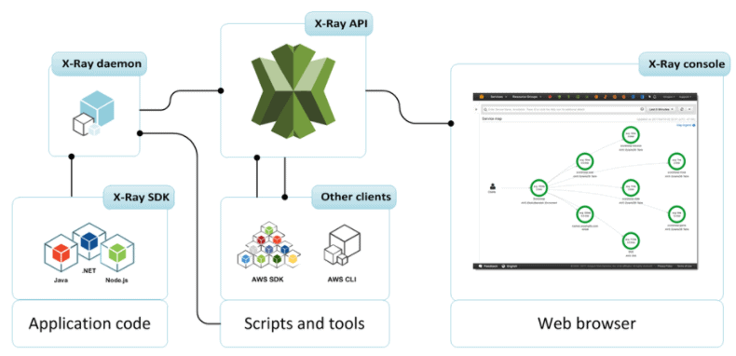

**Note:**Check Our Blog on [**AWS SNS**](https://k21academy.com/amazon-web-services/aws-solutions-architect/amazon-simple-notification-service/)for an overview.

It uses trace data from your AWS resources that power your cloud applications to make a point-by-point detailed service graph. The service graph shows the customer, your front-end service, and backend services that your front-end service calls to handles requests and persist data. The use of the service graph is to improve the performance of your applications.

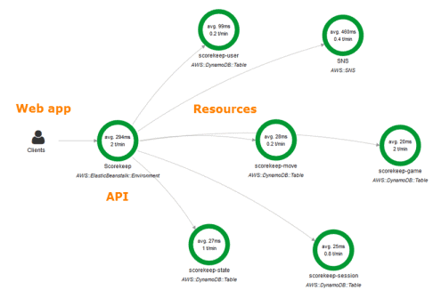

**Note:**Check Our Blog on [**AWS Storage**](https://k21academy.com/amazon-web-services/aws-solutions-architect/aws-storage-overview-types-benefits/)for an overview and the types of storage options offered.

**How does AWS X-Ray work?**

It operates in the following workflow that progresses as follows:

* **Collect Traces:** AWS X-Ray gathers data from each fundamental service of an application.
* **Record Traces:** It combines all the data gathered from each service into singular units called traces.
* **View Service Map:** It generates a map of services used by your application using the trace data. This provides a visual representation of the trace data such as latencies, HTTP status, and metadata for each service.
* **Analyze Issues:** After all the traces are gathered and formated into a service map, developers are now able to identify the performance, unusual behavior of the application, and root issues.

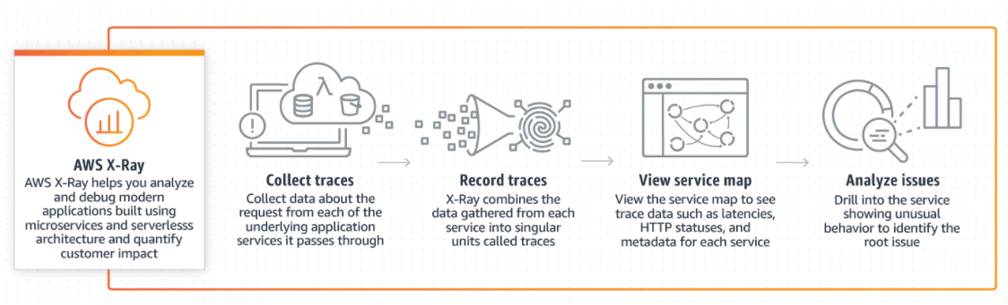

**Features**

The features of AWS X-Ray are:

* **Simple Setup:** It can be used with various applications running on Amazon EC2, Amazon ECS (Amazon EC2 Container Service), AWS Elastic Beanstalk, AWS Lamda. The process to get started with AWS X-Ray is very easy. We just have to integrate our application with X-Ray SDK and install the X-Ray. With Amazon EBS (Amazon Elastic Beanstalk) we just have to integrate the X-Ray SDK with our application as an X-Ray agent is pre-installed on Amazon EBS.
* **End-to-end tracing:** It provides an end-to-end view of requests made to our application. It gives you an application-driven view of requests flowing through your application by accumulating the data gathered from individual services in your application into a single unit called a trace.
* **Service Map:** It creates a map of services utilized by our application with trace data that we can use to identify errors and issues.
* **Server and Client-side latency detection:** X-Ray allows us to visually detect node and edge latency distribution directly from the service map. With this, we can quickly identify issues affecting our application and end-user. It helps us to understand the performance of the application.
* **Data annotation and filtering:**AWS X-Ray allows you to add annotations to data emitted from specific components or services in your application.
* **Console and programmatic access:** We can use X-Ray with AWS Management Console, AWS CLI, AWS SDKs. The X-Ray API enables us to programmatically access the service so we can easily export trace data.
* **Security:** It is integrated with AWS IAM (AWS Identity and Access Management) so that we can control which users and resources have permission to access our traces.

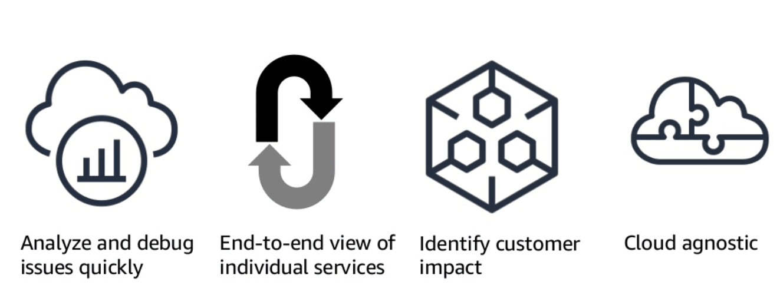

**Step 1: got to AWS x ray 🡪 click select the select the console new Or Old**

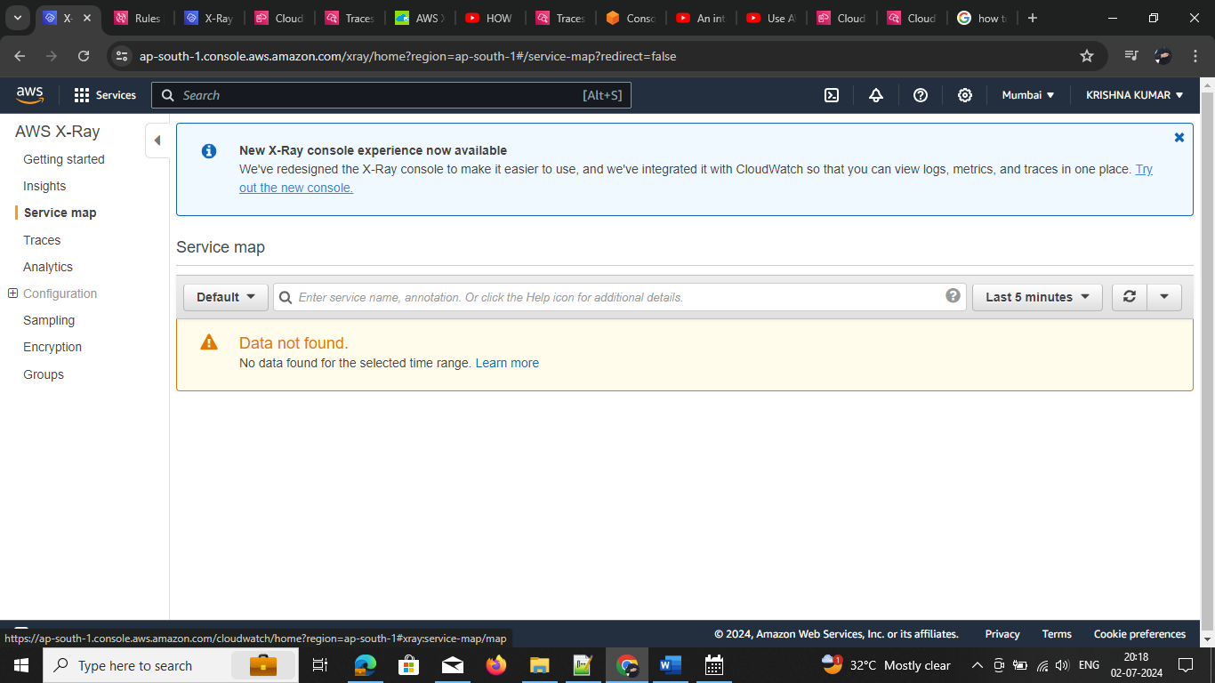

**Step2: click on demo app**

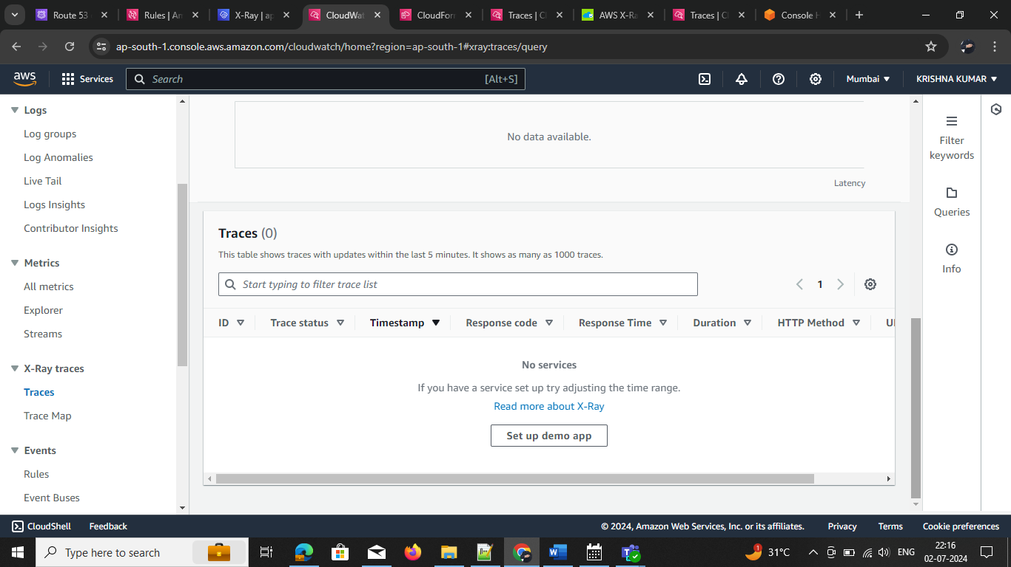

**Step3:** create sample application 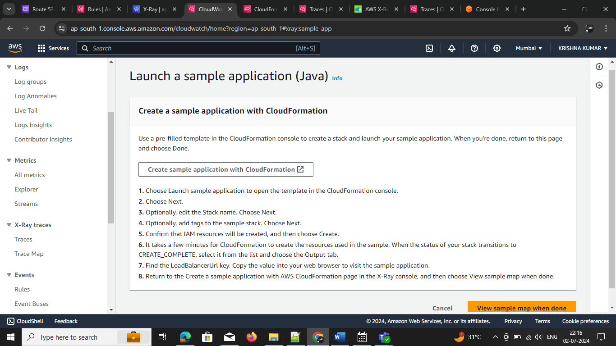CloudFormation

Creating cloud formation

Setp1: Creates a stack

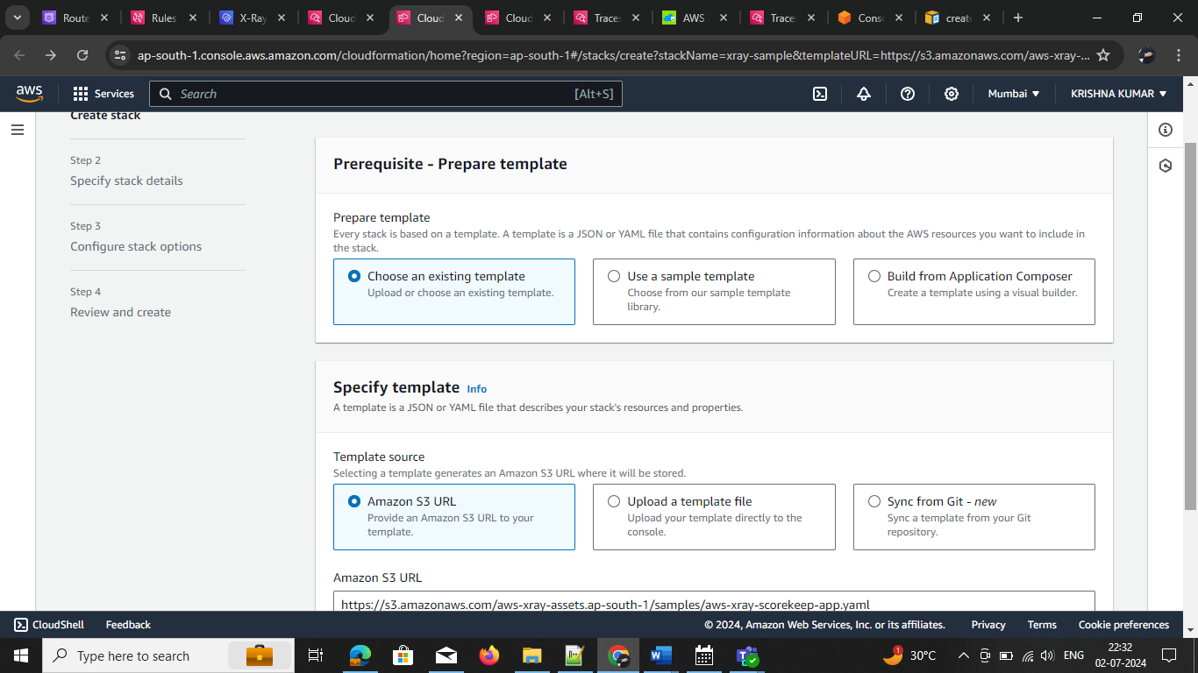

Step2 : give the slack name

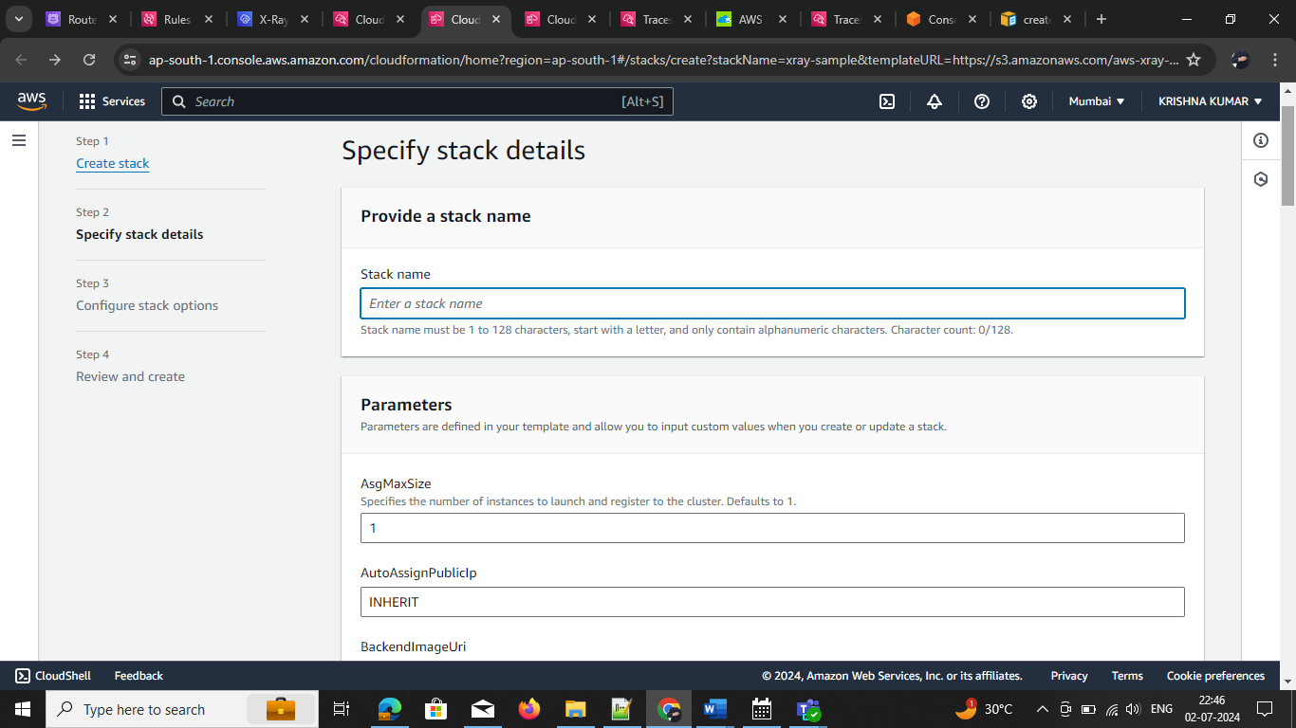

Step3: adding tags, permissions, this optional based on reequipment we need enable it

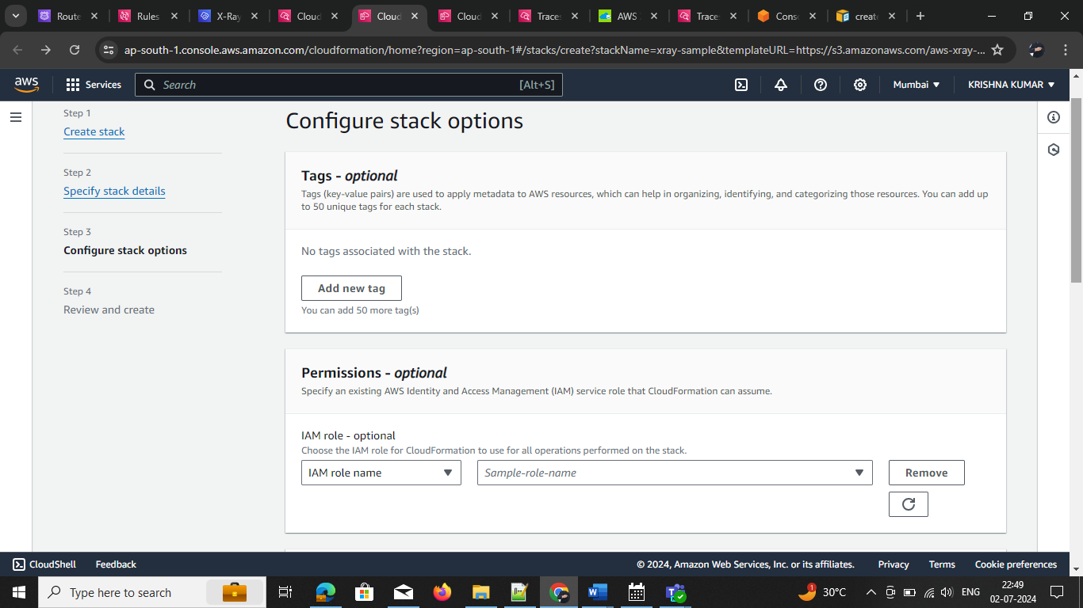

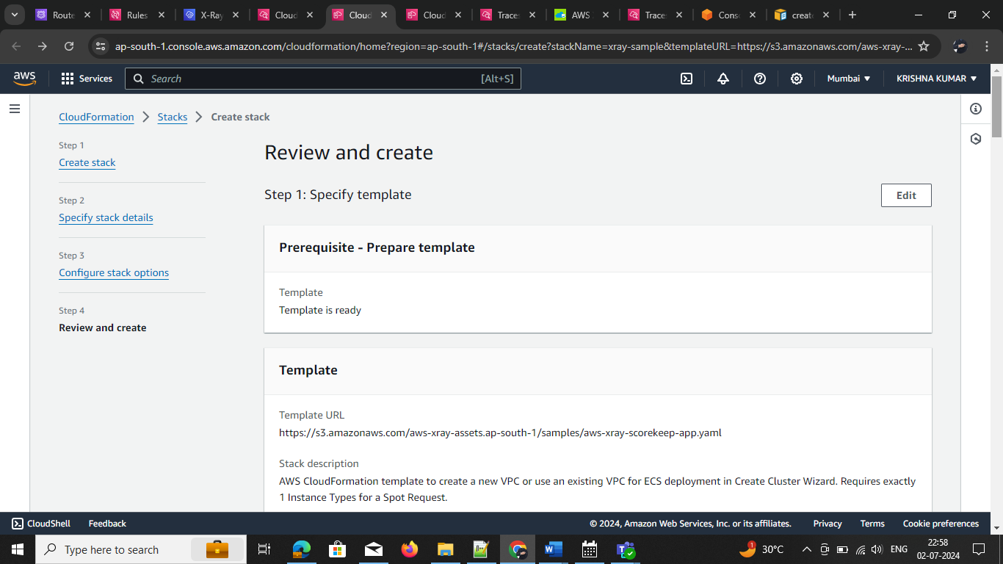step4: Review and create

step4: ones the step up don

